Hotel Management System Demo
User Guide
________________________________________
User Manual
Version 1.0
June 2026

1. System Overview
The Hotel Management System Demo is a comprehensive web-based application designed to streamline hotel operations. It provides an intuitive interface for managing rooms, reservations, guests, check-ins, check-outs, billing, and staff.

1.1 Key Features
- Dashboard with real-time statistics and revenue charts
- Room management with status tracking (Available, Occupied, Maintenance, Reserved)
- Reservation creation, editing, and status management
- Guest profile management with contact details and history
- Streamlined check-in and check-out processes
- Bill generation and payment tracking
- Staff management (admin only)
- Multi-language support (English / Filipino)

1.2 Browser Requirements
- Google Chrome 80+ (recommended)
- Mozilla Firefox 75+
- Microsoft Edge 80+
- Safari 13+
For the best experience, we recommend using the latest version of Google Chrome with a minimum screen resolution of 1280x720.

2. Logging In
To access the Hotel Management System, open your web browser and navigate to the application URL. You will be presented with the login page.
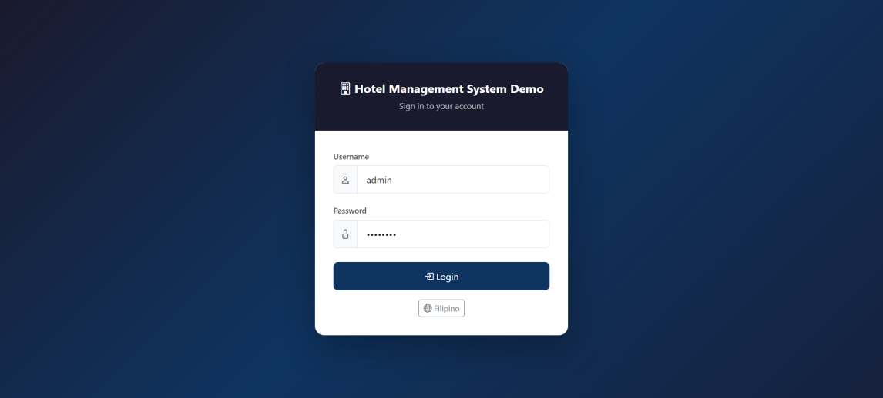
Figure 2.1 - Login Page

2.1 Default Credentials
The system comes with a default administrator account:
- Username: admin
- Password: admin123

2.2 Login Steps
- Enter your username in the "Username" field.
- Enter your password in the "Password" field.
- Click the "Login" button to access the system.
- If credentials are incorrect, an error message will be displayed.
Note: For security reasons, it is recommended to change the default password after your first login.

3. Dashboard
After logging in, you will be directed to the Dashboard. The Dashboard provides a high-level overview of the hotel's current status and key performance metrics.
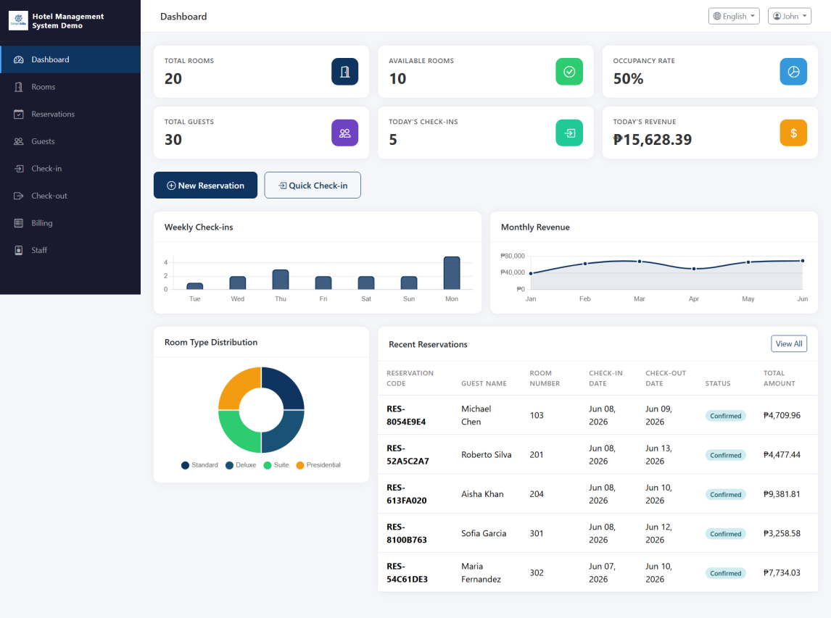
Figure 3.1 - Dashboard Overview

3.1 Statistics Cards
The top section of the Dashboard displays key statistics in card format:
- Total Rooms - Shows the total number of rooms in the hotel.
- Available Rooms - Displays the count of currently available rooms.
- Occupied Rooms - Shows how many rooms are currently occupied.
- Total Revenue - Displays the total revenue generated.

3.2 Charts and Visualizations
The Dashboard includes visual charts that help you analyze trends and patterns in hotel operations, such as occupancy rates over time and revenue breakdowns.

3.3 Quick Actions
The Dashboard may provide quick action buttons to navigate to frequently used features:
- New Reservation - Quickly create a new reservation.
- Check-In - Navigate to the check-in process.
- Check-Out - Navigate to the check-out process.

4. Room Management
The Room Management module allows you to view, add, edit, and delete room records. You can also track room statuses and filter rooms based on various criteria.

4.1 Room List
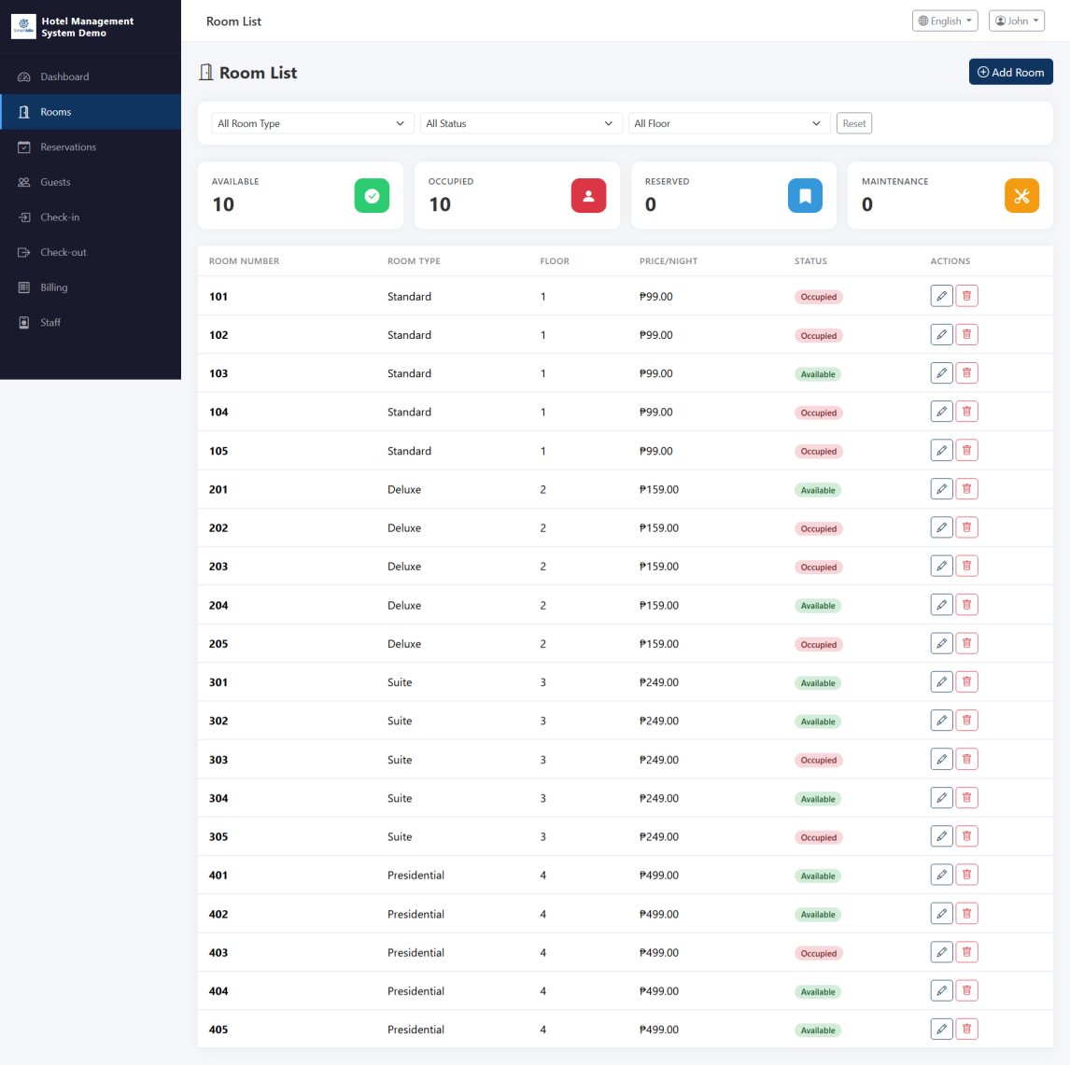
Figure 4.1 - Room List

4.1.1 Status Cards
The room list page displays status summary cards at the top:
- All Rooms - Total count of all rooms.
- Available - Rooms ready for occupancy.
- Occupied - Rooms currently in use.
- Maintenance - Rooms under maintenance.
- Reserved - Rooms reserved for future check-ins.

4.1.2 Filtering
You can filter rooms using the following options:
- Filter by room status (Available, Occupied, Maintenance, Reserved).
- Search by room number or room type.

4.2 Edit Room
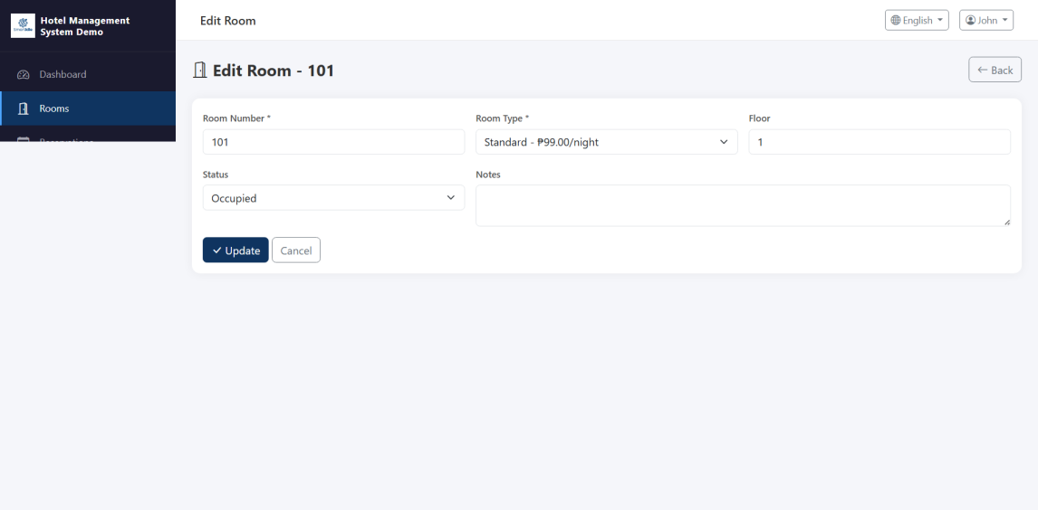
Figure 4.2 - Edit Room
To add or edit a room:
- Click the "Add Room" button or select an existing room to edit.
- Fill in the room details: Room Number, Room Type, Floor, Price Per Night.
- Set the room status (Available, Maintenance).
- Click "Save" to confirm changes.
- To delete a room, click the delete icon and confirm the action.

5. Reservation Management
The Reservation Management module enables you to create, view, and manage guest reservations. Reservations can transition through multiple statuses based on the guest's journey.

5.1 Reservation List
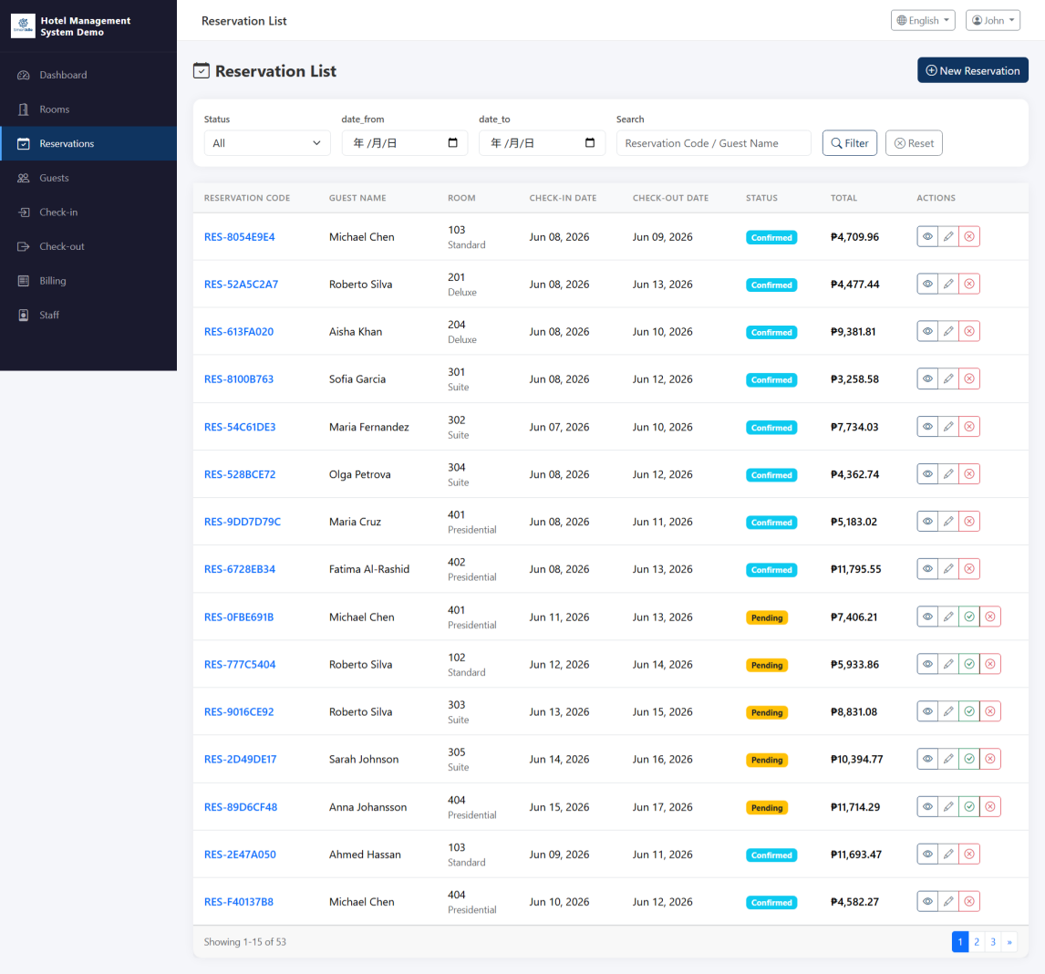
Figure 5.1 - Reservation List
The reservation list displays all reservations with their key details:
- Guest Name - The name of the guest who made the reservation.
- Room Number - The assigned room.
- Check-In Date - The expected arrival date.
- Check-Out Date - The expected departure date.
- Status - Current reservation status.

5.1.1 Filtering Reservations
Use the filter options to narrow down reservations:
- Filter by status (Pending, Confirmed, Checked-In, Checked-Out, Cancelled).
- Search by guest name or reservation ID.

5.2 Reservation Details
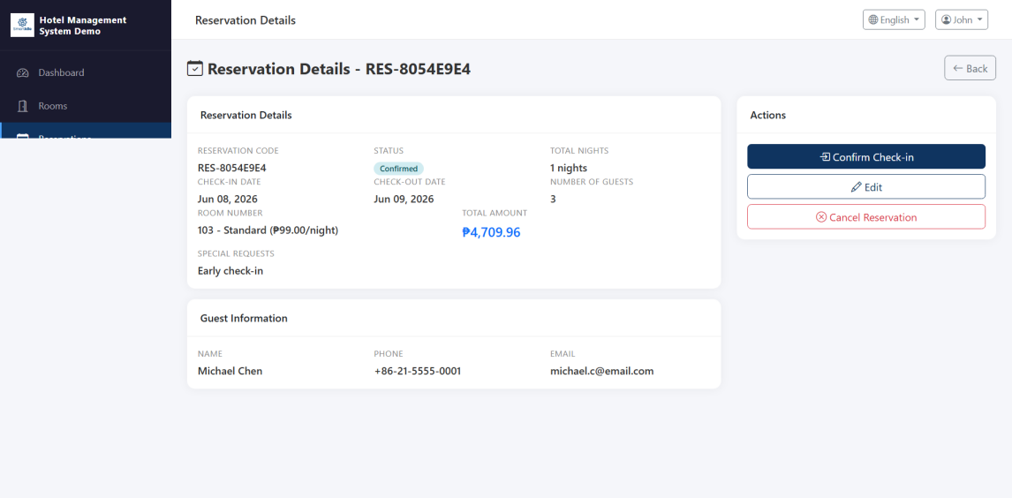
Figure 5.2 - Reservation Details
Click on a reservation to view its full details, including:
- Guest information and contact details.
- Room assignment and pricing.
- Check-in and check-out dates.
- Special requests or notes.
- Current reservation status and history.

5.3 Reservation Status Flow
Reservations follow a status lifecycle:
- Pending -> The reservation has been created but not yet confirmed.
- Confirmed -> The reservation has been confirmed by staff.
- Checked-In -> The guest has arrived and checked in.
- Checked-Out -> The guest has completed their stay and checked out.
- Cancelled -> The reservation has been cancelled.

6. Guest Management
The Guest Management module allows you to maintain a comprehensive database of all guests, including their contact information and stay history.

6.1 Guest List
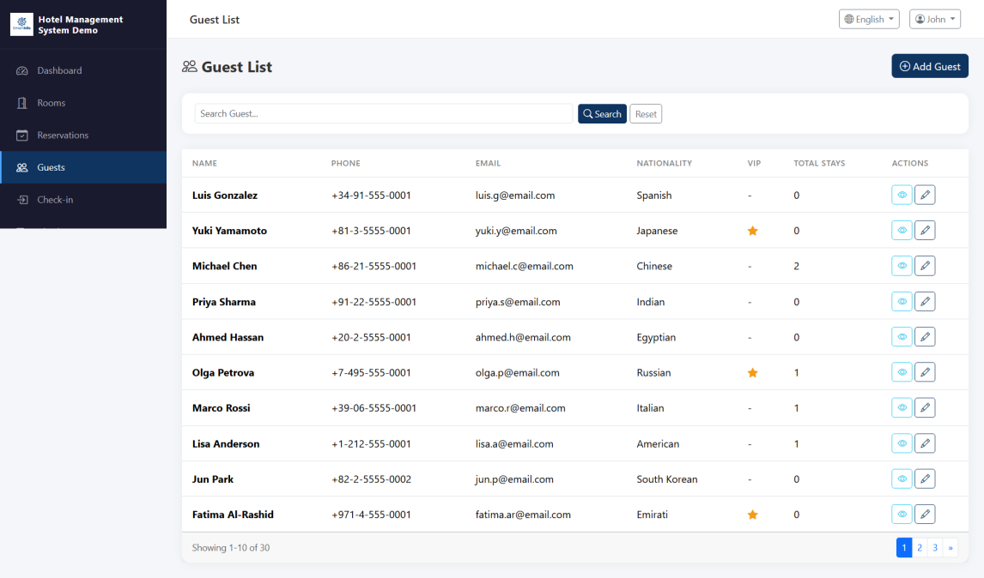
Figure 6.1 - Guest List
The guest list provides an overview of all registered guests:
- Search guests by name, email, or phone number.
- View total guest count.
- Click "Add Guest" to register a new guest.

6.2 Guest Details
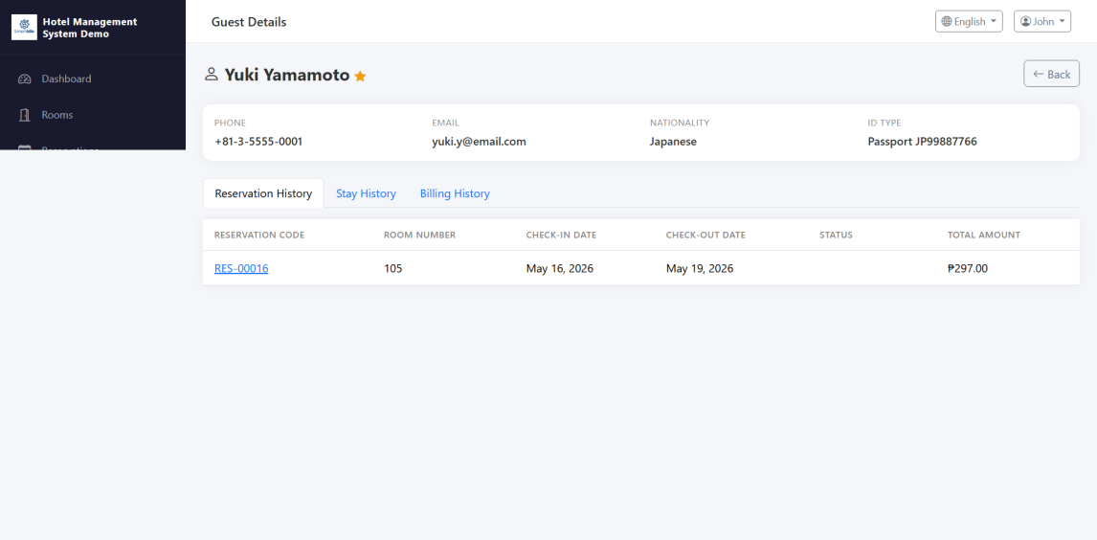
Figure 6.2 - Guest Details
Click on a guest record to view detailed information:
- Personal Information - Name, email, phone number, address.
- ID Information - Government ID type and number.
- Stay History - List of all previous and current stays.
- Reservation History - Associated reservations.
- Notes - Any special notes or preferences.
To add a new guest:
- Click the "Add Guest" button.
- Fill in the required fields (Name, Phone, Email).
- Optionally add address and ID information.
- Click "Save" to register the guest.

7. Check-In
The Check-In module streamlines the process of welcoming guests and assigning them to their rooms upon arrival.

7.1 Check-In List
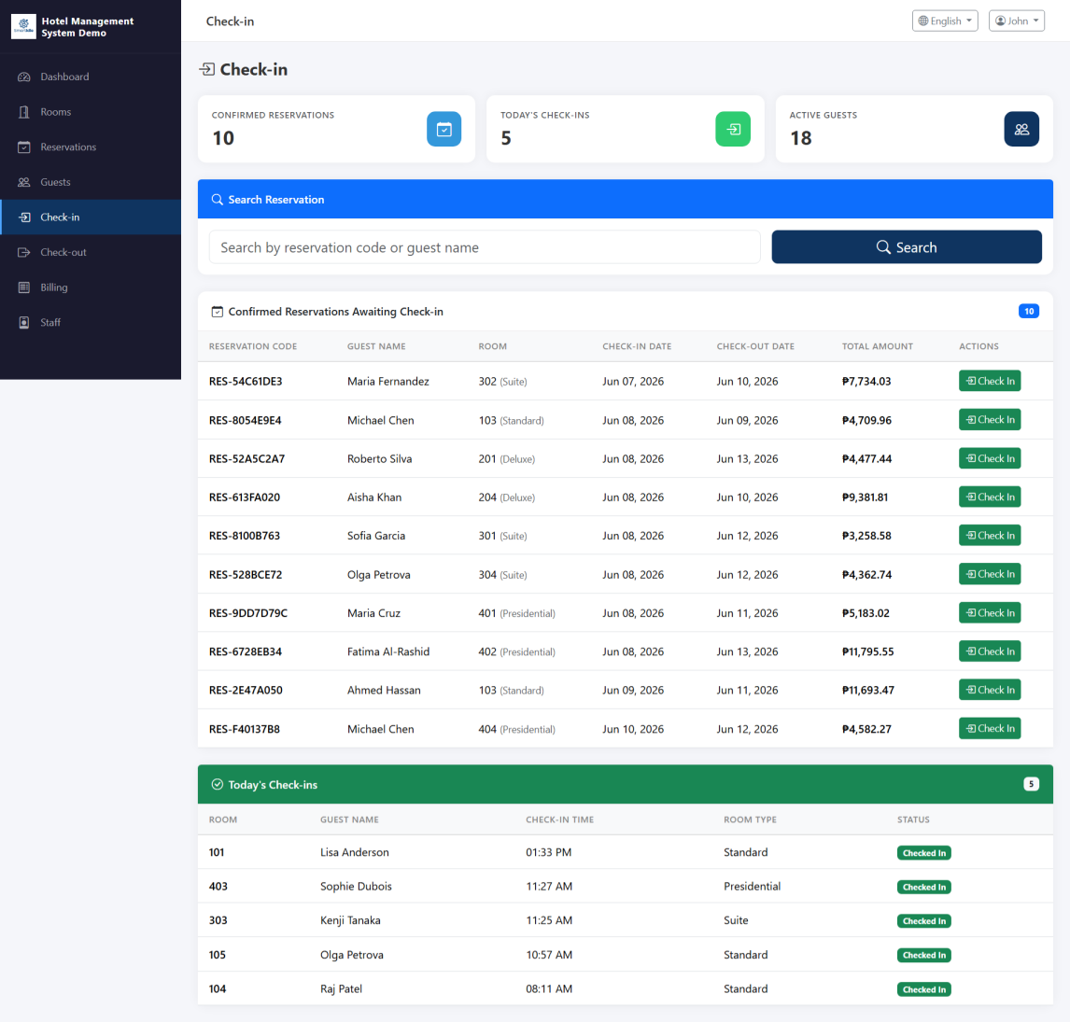
Figure 7.1 - Check-In List
The check-in page displays reservations that are eligible for check-in:
- View all confirmed reservations awaiting check-in.
- Search by guest name or reservation number.
- Filter by date to show today's expected arrivals.

7.2 Check-In Details
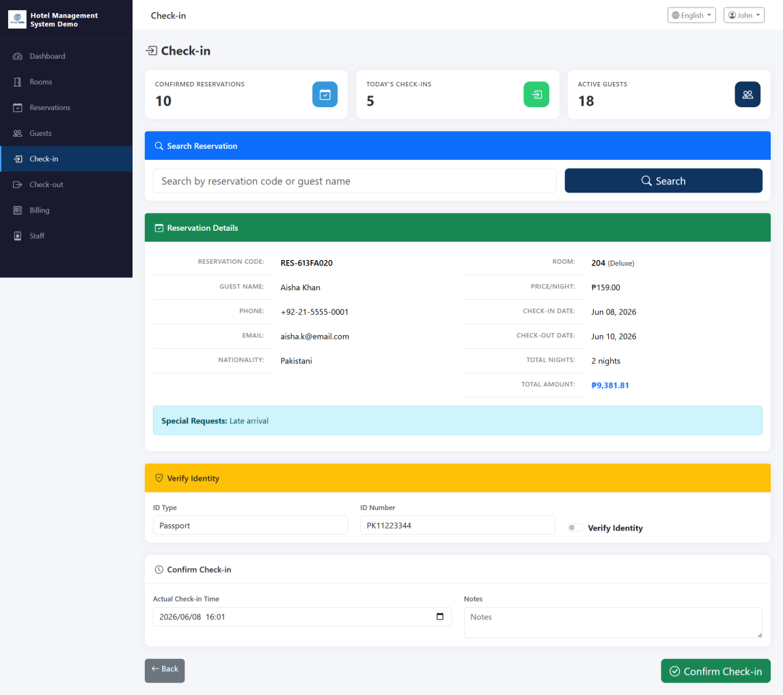
Figure 7.2 - Check-In Details
To process a check-in:
- Locate the guest's reservation from the check-in list.
- Click on the reservation to view details.
- Verify the guest's identity and reservation details.
- Confirm the room assignment and check-in date.
- Click "Check-In" to complete the process.
- The room status will automatically change to "Occupied".

8. Check-Out
The Check-Out module handles guest departures, including bill generation and room status updates.

8.1 Check-Out List
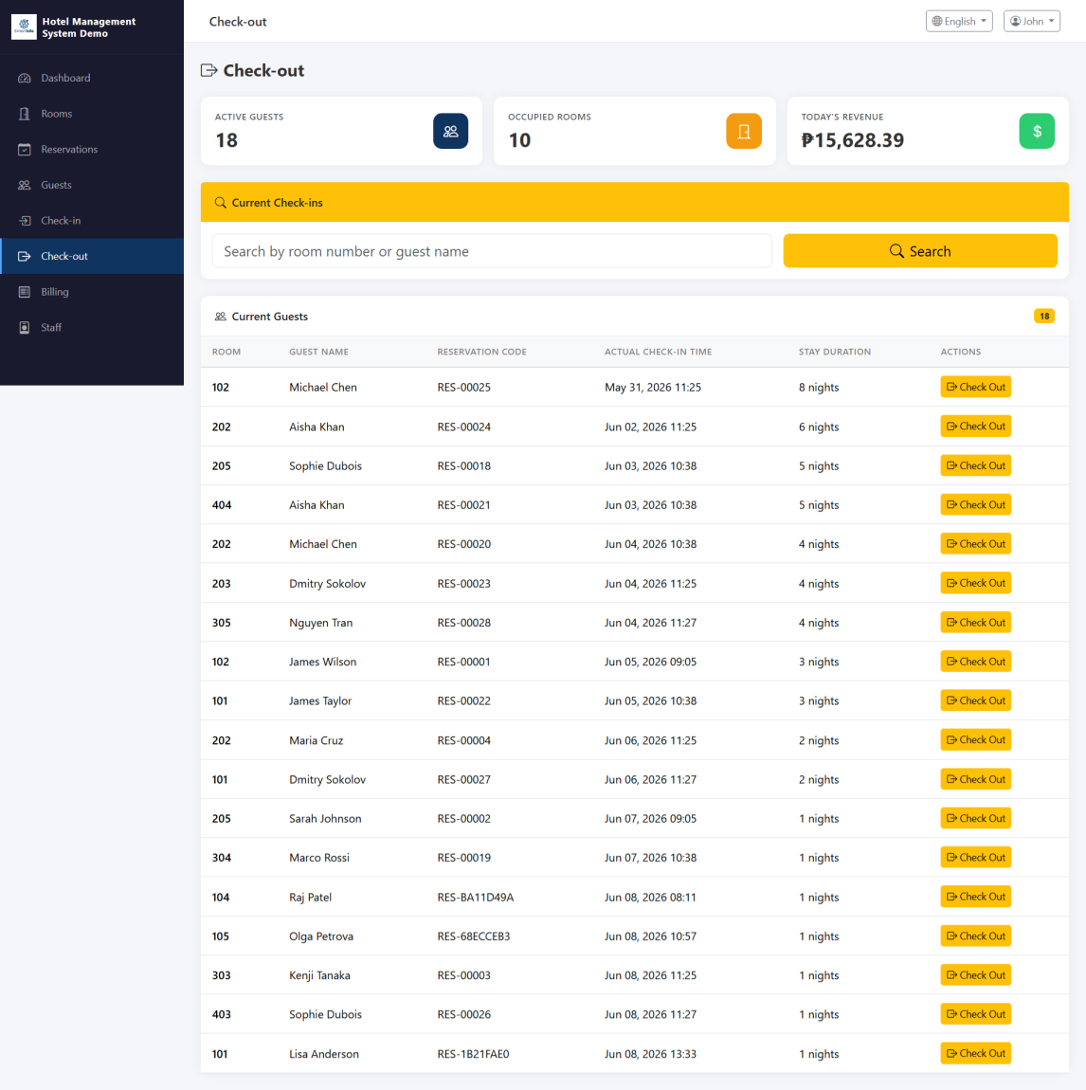
Figure 8.1 - Check-Out List
The check-out page shows currently occupied rooms eligible for check-out:
- View all guests currently checked in.
- Search by guest name or room number.
- Filter by check-out date.

8.2 Check-Out Details
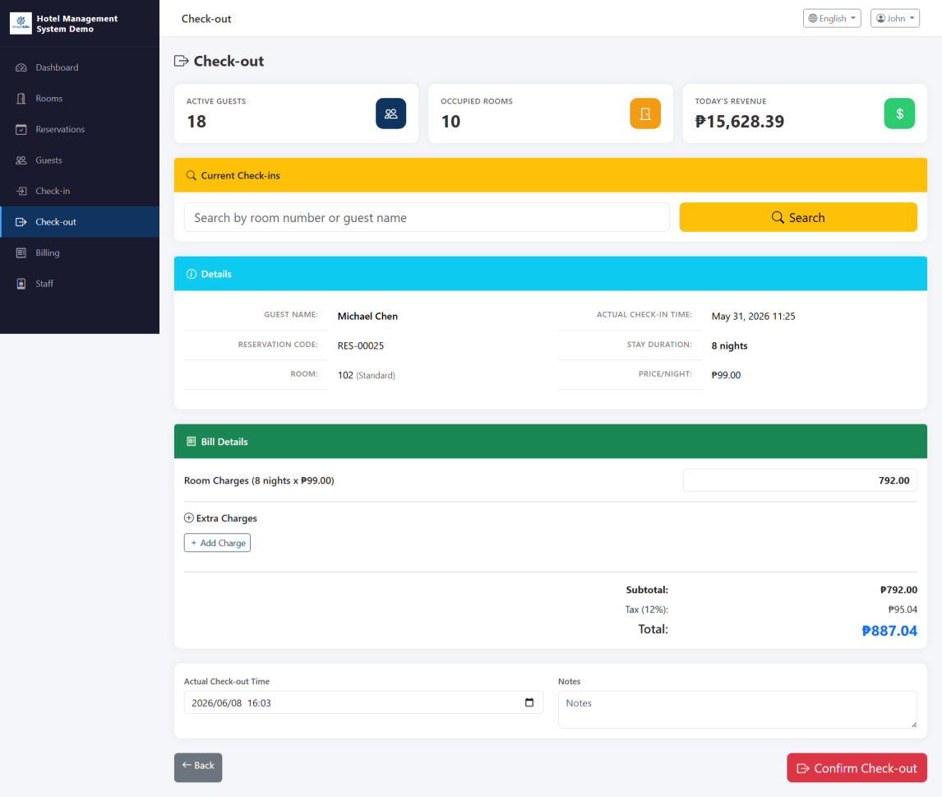
Figure 8.2 - Check-Out Details
To process a check-out:
- Locate the guest from the check-out list.
- Click on the record to view check-out details.
- Review the stay summary and charges.
- Generate or review the final bill.
- Process payment for any outstanding balance.
- Click "Check-Out" to complete the process.
- The room status will automatically change to "Available".

9. Bill Management
The Bill Management module allows you to track all invoices, process payments, and manage additional charges for guest stays.

9.1 Bill List
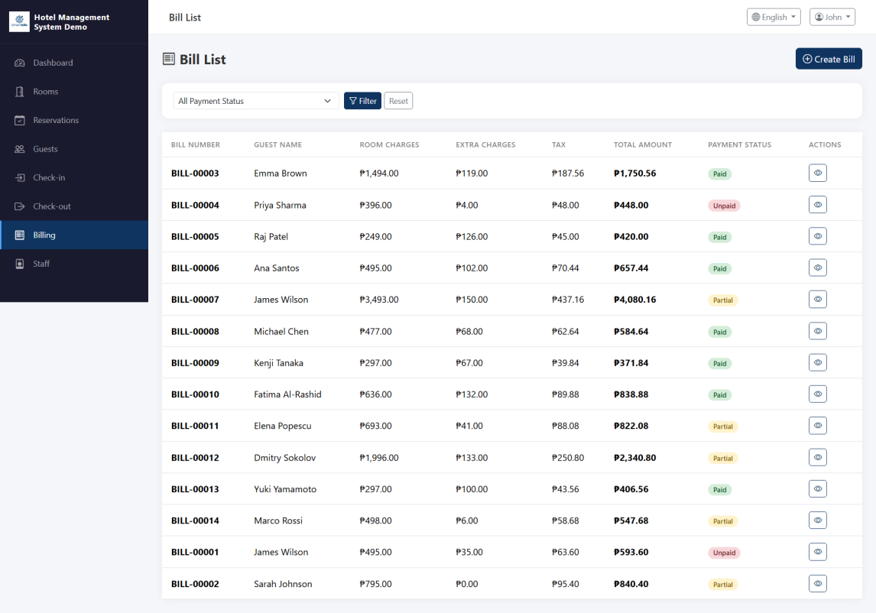
Figure 9.1 - Bill List
The bill list displays all invoices in the system:
- View bill number, guest name, total amount, and payment status.
- Filter by payment status (Paid, Unpaid, Partial).
- Search by guest name or bill number.
- See a summary of total billed amounts vs. collected payments.

9.2 Bill Details
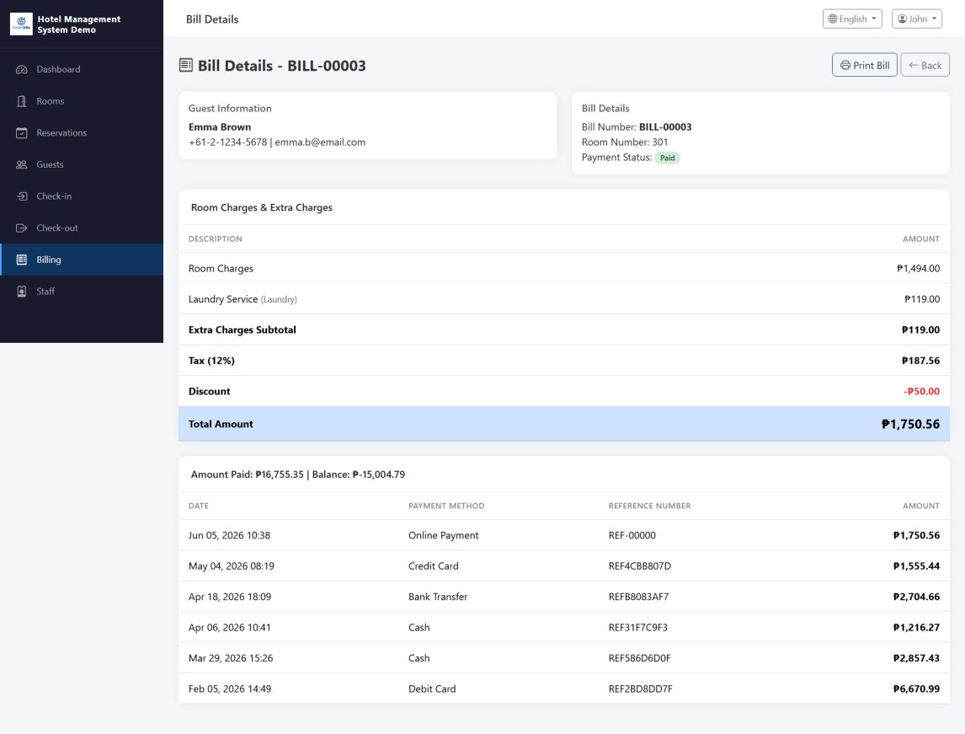
Figure 9.2 - Bill Details
Click on a bill to view its full details:
- Room Charges - The cost of the room for the duration of the stay.
- Additional Charges - Any extra services or items charged to the room.
- Total Amount - The sum of all charges.
- Payment Status - Current payment status.

9.3 Processing Payments
To process a payment:
- Open the bill details.
- Review all charges for accuracy.
- Click "Pay" or "Record Payment".
- Select the payment method (Cash, Credit Card, etc.).
- Confirm the payment to update the bill status.

9.4 Adding Extra Charges
You can add extra charges to a bill during the guest's stay:
- Open the bill for the current guest.
- Click "Add Charge" or similar option.
- Enter the charge description and amount.
- Save the charge. It will be added to the total bill.

10. Staff Management
The Staff Management module is accessible only to users with administrator privileges. It allows you to manage staff accounts and their roles within the system.

10.1 Staff List
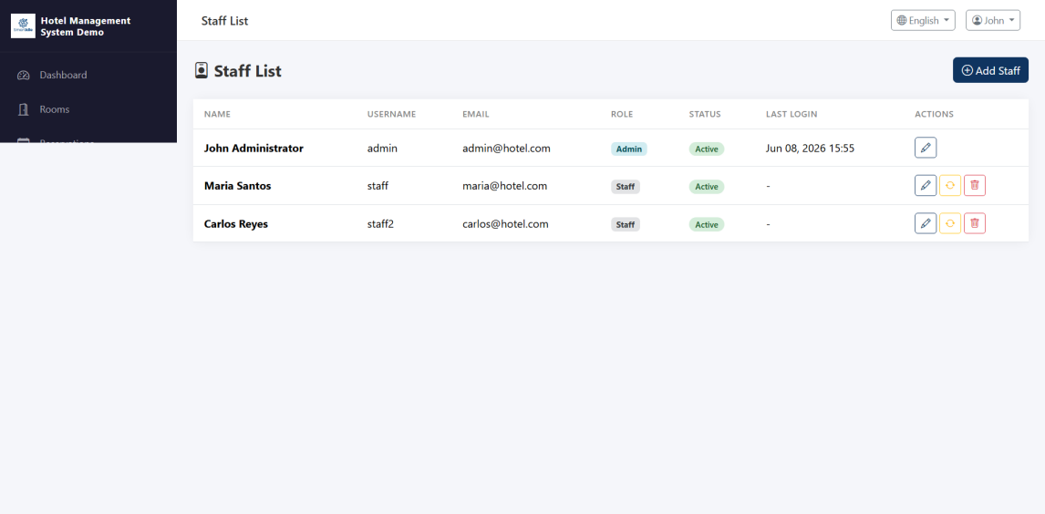
Figure 10.1 - Staff List
The staff list displays all staff members:
- View staff name, role, email, and status.
- Search staff by name or role.
- Add new staff members or edit existing ones.

10.2 Edit Staff
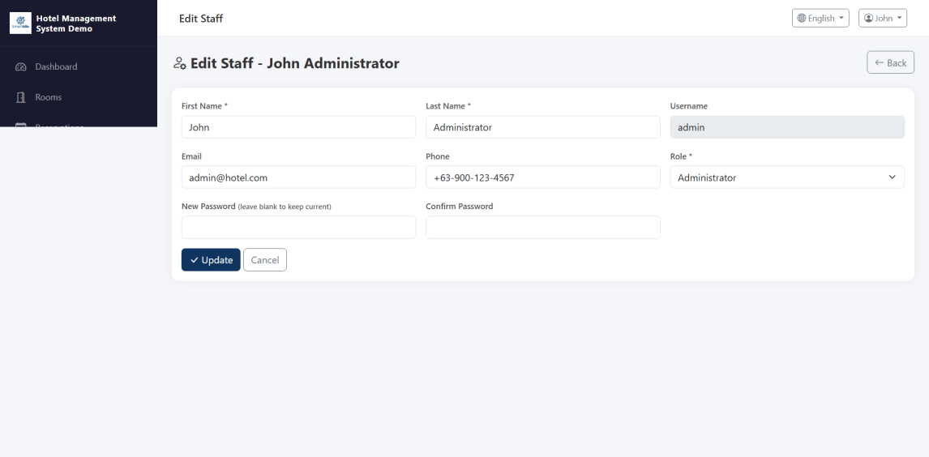
Figure 10.2 - Edit Staff
To add or edit a staff member:
- Click "Add Staff" or select an existing staff member to edit.
- Fill in the staff details: Name, Email, Role, Phone.
- Set the staff status (Active / Inactive).
- If adding a new staff member, set their login credentials.
- Click "Save" to confirm the changes.
Note: Staff Management is only visible to administrator users. Non-admin users will not see this module in the navigation menu.

11. Language Switching
The Hotel Management System supports multiple languages to accommodate diverse users. Currently, the system supports English and Filipino (Filipino language).

11.1 How to Switch Languages
To change the system language:
- Look for the language selector in the navigation bar or header area.
- Click on the current language to open the dropdown.
- Select your preferred language:
  - English - The default system language.
  - Filipino - Filipino language interface.
- The interface will update immediately to reflect the selected language.

11.2 Supported Languages
- English (Default) - All menus, labels, and messages are displayed in English.
- Filipino - All menus, labels, and messages are translated to Filipino.
Note: The language preference is typically saved per session. You may need to switch languages again after logging out and logging back in.

